**FLEET UPDATES VERSION 4.6**

**Note: Sample lang ang mga data sa screenshots.**

1. Pwede na mag change ng Trip Date hanggat hindi pa nakakapag departure ang truck sa fleet.
   1. In Trip Summary, right click the trip you want to change the Trip Date.
   2. Then, select Change Trip Date
   3. Then, modify Trip Date
   4. Then, click Save button
   5. Then, authentication required, input password.
   6. Then, click Ok button.

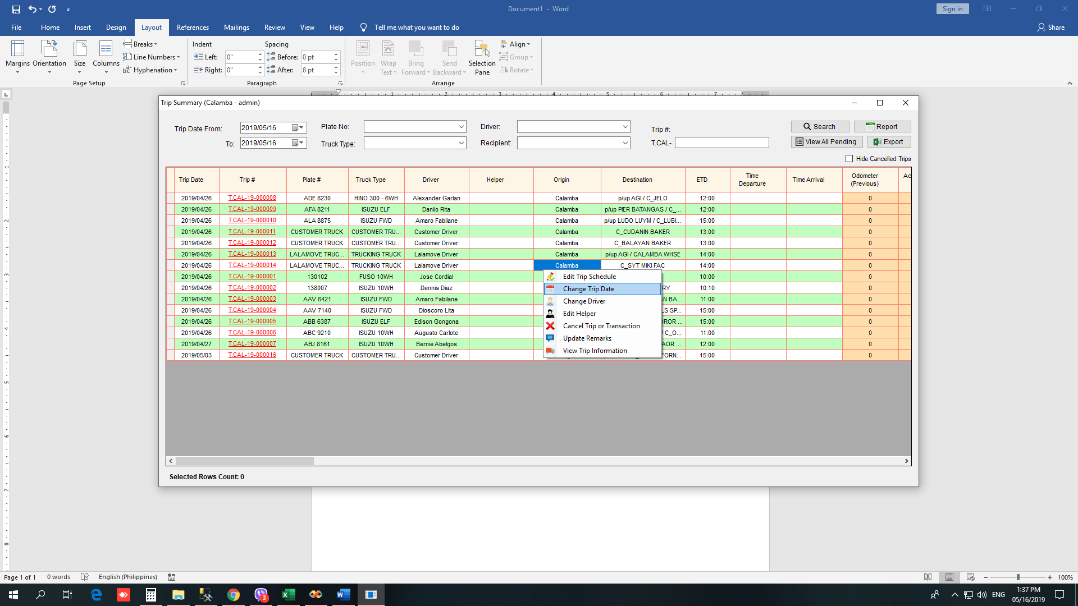

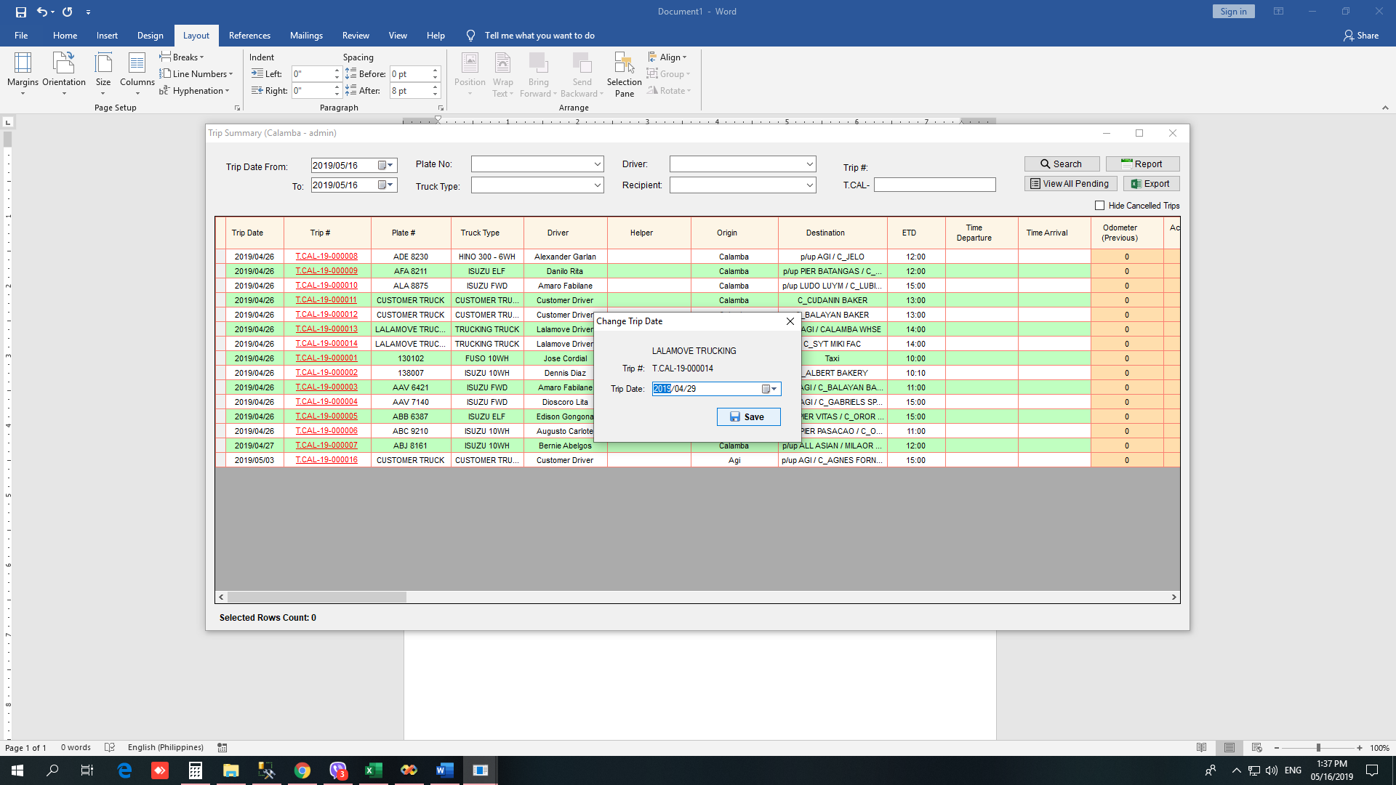

1. Sa Trip Dispatch Summary, Step 3, hindi na naka-list ang items, kundi per Transaction# na ang nasa list.

